America 1919-1941

In this module you will study:

After WWI – isolationism

Tariffs and Immigration

1920s: Prosperity and Poverty

The ‘Roaring Twenties’

Crash and Depression

Effects of the Depression

The New Deal – measures

The New Deal – evaluation

In this module you will learn:
- FIVE reasons the America people were isolationist [IMAGE]
- TWO principles of the Fordney-McCumber Act
- FOUR reasons Americans wanted high tariffs [WAIF]
- THREE reasons Americans wanted to stop immigration [PRT]
- THREE laws to control immigration
- THREE measures to 'Americanize' immigrants
- NINE indications of a booming economy in the 1920s [CI SUCCESS]
- TEN reasons why industry boomed in the 1920s [PAT GOT CASH]
- EIGHT weaknesses of the American economy in the 1920s [FLOP CUTS]
- FIVE aspects of the 'Roaring Twenties' [POWER]
- SIX examples of racism in 1920s America [HACKLE]
- FIVE aspects of the Black renaissance [RHINO]
- SIX factors leading to Prohibition [ACRIME]
- SIX ways prohibition was a failure [DAMAGE]
- THREE ways Prohibition was a success [ALE]
- FOUR causes of the Great Crash of 1929
- SEVEN causes of the Great Depression of the 1930s
- SEVEN ways the Great Depression was terrible [Some Farmers Were Handling Hardship Very Badly]
- THREE ways the Great Depression was not as bad as it is often painted
- THREE aspects of the First New Deal [Can Fdr Achieve]
- FIVE aspects of the Second New Deal [New Social Standards 'N Fairness]
- FIVE successes of the New Deal [5Rs]
- THREE failures of the New Deal [3Ds]
- FIVE opponents of the New Deal [BRASS]

How Did America React to the end of World War I?

There is a traditional explanation of this, that America didn't join the League of Nations because it was 'isolationist'. This is the simplistic view that you will find in most textbooks.

You can add to this more specific knowledge about the political battle between Wilson and his opponents, which ended in the rejection of the Treaty by the Senate.

You also need to know, however, that this is a very old-fashioned view of events, and the modern view of historians say that neither Americans not the Senate were really isolationist AT ALL, and that the Treaty was lost rather by Wilson's stupidity.

1. The Traditional Explanation  The American people had not wanted to go into World War One - America did not join in until 1917 - and when the war ended they rejected the Treaty of Versailles and the League of Nations. This is called 'isolationism' - the desire to keep out of foreign affairs.  American people were isolationist because [IMAGE]:  a. Isolationism:  America regarded itself as the 'New World' and did not want anything to do with the 'Old World', which they saw as being corrupt, old-fashioned and full of dangerous ideas like Communism. When Wilson went to the Versailles Conference, he was the first US President EVER to visit Europe. Most Americans liked the Monroe Doctrine of 1823, that America should stay out of Europe's affairs, and Europe should stay out of America's.  b. Money:  American businessmen were worried about the COST of the League - paying taxes to pay for its organisation, and losing trade if it decided to impose sanctions.  c. American soldiers:  100,000 soldiers had died in the First World War, and many Americans couldn't see why American soldiers should die keeping peace elsewhere in the world.  d. German immigrants:  Many Americans were immigrants from Europe and they still had ties there. So German immigrants HATED the Treaty of Versailles just as much as the Germans in Germany. (Also, many Irish immigrants HATED Britain so much they didn't want to have anything to do with a League of Nations with the British in it).  e. Empires:  The American colonies had once been part of an empire, but the American revolution was about freedom from empire. The Treaty of Versailles hadn't abolished the British Empires (indeed, it had added Mandates to them), and many Americans did not want to be part of a Treaty or a League with upheld the British Empire. | Source A  We are not internationalists, we are American nationalists.  Theodore Roosevelt, speaking in 1919  Roosevelt was a former President of the US.  Source B  Senator Borah's speech  We have entangled ourselves with all European concerns … dabbling in their affairs. In other words, we have surrendered, once and for all, the great policy of "no entangling alliances" upon which this Republic has been founded for 150 years.  [Acting according to the decisions of a League] is in conflict with the right of our people to govern themselves free from all restraint of foreign powers....  A real republic can not commingle with the discordant and destructive forces of the Old World. You can not yoke a government of liberty to a government whose first law is that of force. India, sweltering in ignorance and burdened with inhuman taxes after more than one hundred years of dominant rule; Egypt, trapped and robbed of her birthright; Ireland, with 700 years of sacrifice for independence – this is the atmosphere in and under which we are to keep alive our belief in democracy.  Senator Borah (19 November 1919).  Borah, a Republican Senator and isolationist, was speaking in the Senate debate abut the Treaty. India, Egypt and Ireland were in the British Empire  Extra:  Isolationism/ Money/ American soldiers/ German immigrants/ Empire - can you see any of these prejudices influencing Senator Borah's speech in Source B?

2. The Political Battle  ● America was a democracy - Wilson could not sign the peace himself, but had to ask Congress to agree to the Treaty of Versailles he had negotiated.  ● However, in the 1918 Elections the Republican Party had won a majority in the Senate, and Wilson was a Democrat.  ● The Republican opposition to Wilson was led by Senator Henry Cabot Lodge - he and Wilson hated each other.  ● Wilson set off on a nation-wide tour to drum up support for the Treaty (see his speech at Pueblo in favour of the League, September 1919), but the overwork caused a stroke and he had to stop.  ● He went to Congress - the first American president to do for 130 years - but could not read his speech properly.  ● The Treaty was defeated in Congress in November 1919.  ● James Cox (Wilson's successor as leader of the Democrats) campaigned for the Treaty in the 1919 election, but his Republican opponent Warren Harding fought under the slogan ‘return to normalcy’ and won the election.  ● The Treaty of Versailles was finally rejected by the Senate in March 1920. | Source C  The stage is set, the destiny disclosed. It has come about by no plan of our conceiving, but by the hand of God. We cannot turn back. The light streams on the path ahead, and nowhere else.  Wilson's speech to Congress (10 July 1919)  Source D  Contemptible, narrow, selfish, poor little minds that never get anywhere but run around in a circle and think they are going somewhere.  Woodrow Wilson, speaking in 1919  Wilson was describing what he thought about those people who wanted to stay out of world affairs.

3. The Modern View
Modern historians deny that America rejected the Treaty because of isolationism.
They point out that:
● Americans were NOT isolationist - opinion polls at the time showed that more than 80% of Americans supported the idea of a league of nations.
● Only a dozen Senators were out-and-out isolationists like Senator Borah.
● Lodge was NOT an isolationist. He believed in a league of nations and he wanted to build up an overseas US empire. What he and the Republicans wanted were 14 changes in the Treaty (the '14 reservations').
● Many Democrats could have accepted the 14 changes.

So why then did the Treaty fail - simply, say modern historians, because of Wilson stupidity.
He WOULD not compromise
He would not accept ANY change.
And in the end - rather than accept the 14 Reservations - Wilson's 23 supporters voted AGAINST the Treaty and destroyed it!

How Did the American Government encourage Isolationism?

Top of Form
The whole aim of practical politics is to keep the public alarmed (and hence clamorous to be led to safety) by menacing it with an endless series of hobgoblins, all of them imaginary.
HL Mencken (1923)
Tariff, noun,
1. a list or table of duties or customs payable on the importation or export of goods.
2. a duty on any particular kind of goods.
Hutchinson Educational Encyclopedia Dictionary (2000)

The new government of Warren Harding brought in two developments which are often attributed to 'isolationism' (although they had other causes). The first was to increase tariffs on foreign imports to protect American industry. The second was to restrict immigration.

1. The Fordney-McCumber Act, 1922  Wilson believed in low tariffs. He had reduced tariffs in 1913, and refused to increase them.  Demand was growing, however, for higher tariffs (Source B). As soon as he became President, Warren Harding passed an Emergency Tariff (May 1921) to increase duties on food imports, and in 1922 Congress passed the Fordney-McCumber Tariff. This had two principles:  a. 'Scientific tariff': this linked tariffs to the wages in the country of export. If wages in, say Italy, were very low, then Italian goods were given a proportionately higher tariff. This negated the effect of lower wages in competitor countries.  b. 'American Selling Price': this linked tariffs to the price of American goods, not to the cost of production. A German company might be able to produce, say, a certain chemical for $60, but if the selling price in America was $80, and the US tariff was 50%, the tariff would be $40. This meant that foreign imports were ALWAYS more expensive than American-produced goods, however cheaply they had been made.  The Fordney-McCumber Act established the highest tariffs in history, with some duties up to 400% and an average of 40%.  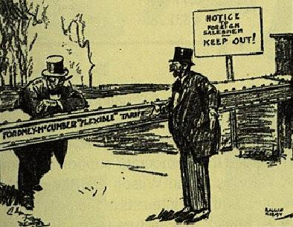  An anti-tariff American cartoon of the time, linking the tariff to isolationism. The French man is saying: 'But Monsieur, where does it end'.  In the long-run, the Fordney-McCumber Act damaged the American economy, because other countries retaliated by putting up their duties and stopping American exports. However, for the moment, America was a huge new country, and there was plenty of demand at home. | Source A  If ever there was a time when Americans had anything to fear from foreign competition, that time has passed. If we wish to have Europe settle her debts, governmental or commercial, we must be prepared to buy from her.  Woodrow Wilson, speaking in March 1921  Wilson had just vetoed the Emergency Tariff Bill, just before he handed over the Presidency to Harding.  Source B  Why Americans wanted high tariffs [WAIF]  Tariffs stop imports!  a. Wartime boom: American business had boomed during the war - possibly because the countries involved in the war hadn't been able to sell goods to America - and American businessmen wanted this to continue.  c. American wages: American wages were rising, and American businessmen feared that low wages in Europe would allow European firms to undercut them. Thus Joseph Fordney claimed that tariffs would protect American workers' jobs.  b. Isolationism: American isolationists wanted America to be self-sufficient .  d. Farm Bloc: Overproduction was causing a depression in farming. Farmers hoped that protection would help keep prices up.  Extra:  Is the Fordney-McCumber Act an example of 'isolationism'?
2. Immigration Quotas  ALL Americans were immigrant families, of course, but until 1890 most immigrants were 'WASPs' (white Anglo-Saxon Protestants) from the wealthier countries of Europe such as Britain, Germany and Sweden. After 1890, more immigrants started arriving from Eastern Europe and Asia.  Demand was growing, however, to slow down immigration (Source F), and there followed a number of laws to restrict immigration:  a. 1917: Immigration Law  This required all immigrants to prove they could read English, banned all immigration from Asia, and charged an immigration fee of $8.  b. 1921: Emergency Quota Act  This stated that the number of immigrants from 'the eastern hemisphere' could not be more than 3% of the number already in America in 1910. It set the maximum number of immigrants in any year at 357,000.  c. 1924: Reed-Johnson Act  Maximum number of immigrants in any year at 154,000. Quota from eastern hemispherereduced to 2% of those already in America in 1890; the South and the East of Europe were thus only allowed to send 20,000 immigrants per year, and non-Europeans only 4,000.  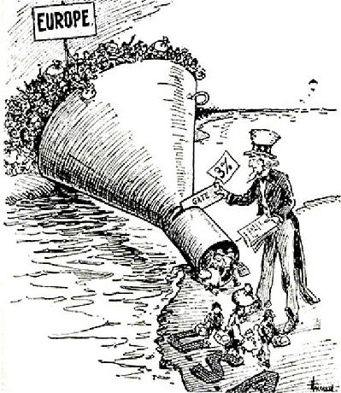  An American cartoon of 1921  At the same time measures were taken to 'Americanize' immigrants:  ● The Federal Bureau of Naturalization organised naturalization proceedings, and patriotic 'Americanization Day' rallies and Fourth of July celebrations.  ● The Federal Bureau of Education organised courses on politics and democracy to prepare immigrants for the 'citizenship exam'.  ● The courts clamped down harshly on political crimes by immigrants. (The case you MUST know about is the trial of Sacco and Vanzetti - two immigrants from Italy who were anarchists - who in 1920 were found guilty of armed robbery and murder (and executed in 1927), even though the defence produced 107 witnesses that they were elsewhere at the time, and in 1925 the actual murderer came forward and gave himself up ... the jury did not believe the defence witnesses because they were all Italian immigrants).  Not all this was racism and prejudice - many social workers saw it as a way to help immigrants out of the terrible poverty many of them lived in. | Source C  America is God's Melting Pot, where all the races of Europe are melting and reforming! Germans, Frenchmen, Irishmen and Englishmen, Jews and Russians - into the Melting Pot with you all! God is making the American.  Israel Zangwill, The Melting Pot (1908)  Source D  New arrivals should be limited to our capacity to absorb them into the ranks of good citizenship. America must be kept American ...  I am convinced that our present economic and social conditions warrant a limitation of those to be admitted. Those who do not want to be partakers of the American spirit ought not to settle in America.  President Coolidge, Message to Congress, 1923  Source E  As soon as they step off the decks of their ships our problem has begun - bolshevism, red anarchy, black-handers and kidnappers, challenging the authority and integrity of our flag…  Thousands come here who never take the oath to support our constitution and to become citizens of the United Sates. They pay allegiance to some other country while they live upon the substance of our own. They fill places that belong to the loyal wage-earning citizens of America… They constitute a menace and a danger to us every day.  Speech by an American Senator, 1921  Source F  Why stop immigration [PRT]  Racism and mistrust!  a. Prejudice: after 1880, many immigrants were poor Catholics and Jews from eastern Europe. This worried the WASPs; one Senator in the 1920s said that the American pioneers were becoming 'a race of mongrels'.  b. Red scare: Communism terrified Americans; a number of bombs were planted in 1919-21, one by an immigrant Italian. Immigrants were suspected of being communists and anarchists.  c. Trade Unions: opposed immigration because they feared that immigrants would work for lower wages and take their jobs.  Extra:  1. Prejudice/ Red Scare/ Trade Unions - can you see any of these prejudices influencing the statements in Sources D and E?  2. Why do you think the 1924 Act pushed the Census year back from 1910 to 1890
Bottom of Form

How far did the USA achieve prosperity in the 1920s?
A 'how far' question ALWAYS indicates that there are two sides to the argument. So, on the one hand you can cite evidence of burgeoning prosperity - on the other hand there is evidence that many did not share in the prosperity. | Source A  We are not internationalists, we are American nationalists.  Theodore Roosevelt, speaking in 1919  Roosevelt was a former President of the US.  Source B  Why Industry boomed [PAT GOT CASH]  a. Population growing rapidly increased demand for consumer goods.  b. Abundant raw materials – esp. coal, iron and oil – allowed cheap production  c. Tariffs – protected American industry from competition  d. Government – the government relaxed regulations and reduced taxes (this is called ‘laissez faire’)  e. Opportunities of New Technology (e.g. electrical goods, radio, film, nylon)  f. Techniques of production– Ford’s Assembly line method, and Frederick Taylor’s time and motion  g. Cycle of prosperity – increased prosperity increased prosperity.  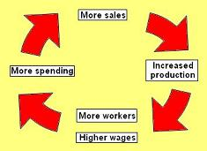  h. Advertising (e.g. billboards, radio commercials,)  i. Sales methods (e.g. commercial travellers, mail order, chain stores such as Woolworths)  j. Hire Purchase – instalments allowed people to buy now, pay later.  Source C  'The business of America is business.'  'The man who builds a factory, builds a temple. The man who works there, worships there.'  President Coolidge  Source D  We in America today are nearer to the financial triumph over poverty than ever before in the history of our land. The poor man is vanishing from us. Under the Republican system, our industrial output has increased as never before, and our wages have grown steadily in buying power.  President Hoover, speaking in 1928  During his election campaign, Republicans promised 'a chicken in every pot and a car in every backyard'.

1. The Booming Economy
Between 1922 and 1929 the annual Gross National Product of the USA increased by 40%. The average income per head increased by 27%.

Highlights of the boom included [CI SUCCESS]:

a. Consumer boom – growth of personal possessions (c.f. Woolworths, hire purchase, commercial travellers).
b. Innovation in production methods, especially in the motor industry (by 1925 Ford were producing a car every 10 seconds); this pushed down prices and made goods more accessible for ordinary people (the ‘Tin Lizzie’ cost $850 in 1910, only $295 in 1920).

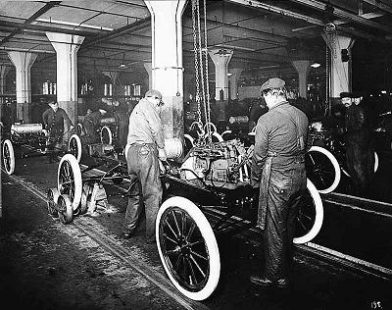

Ford Assembly line

c. Synthetics – the invention of bakelite (the first plastic), cellophane and nylon - and chemicals.
d. Upsurge in car ownership – esp. the Ford Model T; 15 million had been produced by 1927, and the number of Americans owning cars rose from 8 to 23 million.
e. Consumer durables/electrical goods – fridges, washing machines, dishwashers, vacuum cleaners, record players.
f. Communications revolution – number of telephone doubled/ number of radios increased from 60,000 to 10 million.

g. Entertainment industry – Hollywood, Charlie Chaplin, the ‘talkies’ and cinemas, jazz clubs and speakeasies.
h. Stock market – Wall Street boomed (a 'bull' market) with many people buying shares to make a profit. Many new businesses were 'floated' on the stock market.
i. Skyscrapers, highways and urban development.

2. Poverty and Depression  Not every one shared in the prosperity, however, and there were glaring weaknesses in the American economy in the 1920s.  However, there is plenty of evidence that all was not well with the American economy in the 1920s, and in 1928 the 'boom' began to slow down. Particular problems included [FLOP CUTS]:  a. Farming - machinery and overproduction led to rapidly falling prices (wheat prices fell from $183 a bushel in 1920 to 38 cents in 1929). In 1929 average income in of farmers was only 40% of the national average, and many farmers could not afford their mortgage; in 1924, 600,000 farmers went bankrupt. Note also that rural areas did not have electricity, so most country-dwellers were excluded from the consumer boom.  b. Low wage earners - e.g. unskilled and casual workers, or the 2 million who were unemployed - could not share in the prosperity. There were inequalities of wealth; the top 5% earned 33% of the income, while 60% of Americans earned less than $2000, and that 40% were below the poverty line (esp farmers/ Black Americans/ immigrants).  c. Old Industries - overproduction of coal (which was being replaced by oil and gas) led to mine closure and falling wages. In 1929 a coal miners wage was barely a third of the national average income. There were also problems in the textiles industry.  d. Poor Black Americans - 1 million black farm workers lost their jobs in the 1920s. Black workers in the towns in the north were the lowest paid; the only work was low-paying, menial jobs. New York's black Harlem district was segregated and overcrowded, with 250,000 people crammed into an area 50 blocks long and 8 blocks wide. Many people slept in shifts, going to bed when others went to work. ‘Rent parties’ were common on Saturday nights, to raise money to pay the landlord on Sunday.  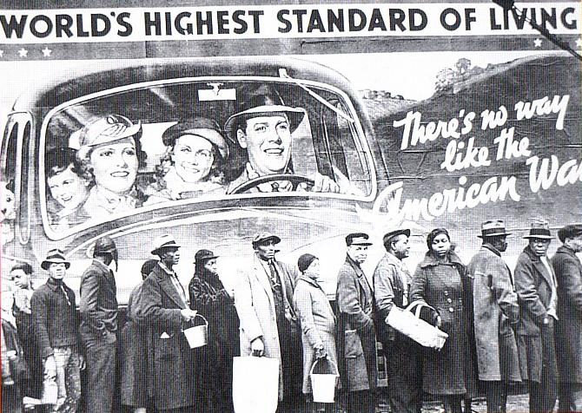  This photo is from the 1930s, but it sums up the position of Black people in the 1920s - they can SEE the prosperity, but they don't SHARE in it.  e. Cartels, trusts and monopolies - ‘fixed the market’ and tried to keep prices high and wages low.  f. Unemployment – new technology was throwing more and more people out of work; the number of unemployed stood at 2 million throughout 1920s.  g. Trade problems - high tariffs were causing other countries to retaliate, as well as reducing the purchasing power of those countries, which made it hard for American companies to export their products abroad. Farmers, who relied on exporting wheat, were especially hard-hit by this.  h. Stock Exchange – the biggest problem; Wall Street was 'over-heating. People were buying shares in imaginary companies. Many bought shares ‘at the margin’ (a person could get a loan of 90% to buy shares) expecting to make enough profit to repay the loan when the shares were resold - brokers’ loans trebled 1926-9. All this threatened disaster if share prices ever stopped rising. | Source E  In the USA too much wealth had fallen into too few hands, with the result that consumers were unable to buy all the goods produced. The trouble came to a head mainly because of the easy credit policies of the Federal Reserve Board, which favoured the rich. Its effects were so profound and so prolonged because the government did not fully understand what was happening or what to do about it.  John A. Garraty, The American Nation (1979)  Source F  In 1929 it was strictly a gambling casino with loaded dice. I saw shoeshine boys buying 50 000 dollars worth of stock with 500 dollars down payment. A cigar stock at the time was selling for 114 dollars a share. The market collapsed. The 114 dollar stock dropped to two dollars, and the company president jumped out of the window of his Wall Street office.  Studs Terkel, Hard Times  Studs was talking to an interviewer in 1970  Source G  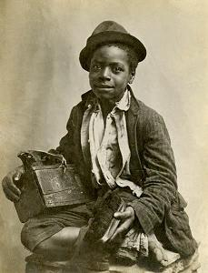  A Black bootblack, 1920  What mood is the photographer trying to create?  Extra:  FLOP CUTS - can you see any of these problems and weaknesses reflected in the statements in Sources E, F and G?

‘The Roaring Twenties’. Is this a good description of 1920s America?

This huge topic is really five topics, each one a big subject, and - as well as a question abut the 'Roaring Twenties' as a whole topic - you have to be prepared for for a specific question on just one of the five topics in the exam.  One the positive side, there were exciting developments in entertainment and women's lives. On the negative side, there was Racism, Prohibition, and Organised Crime. | One way to remember the five aspects of life in America in the 1920s would be POWER:  ● Prohibition  ● Organised crime  ● Women's lives  ● Entertainment  ● Racism
1. Entertainment  If the term 'roaring twenties' applies to anything, it applies to entertainment, in which area there were many exciting developments:  a. Films:  ● movie actors such as Charlie Chaplin, Rudolf Valentino and Mary Pickford became 'stars'.  ● 1927,The Jazz Singer starring Al Jolson, was the first 'talkie'.  ● a well-known early two-colour film was The Toll of the Sea (1922) and two-colour films were common by the end of the 1920s; after 1932, films were produced in three-colour technicolour.  ● Mickey Mouse was created by Walt Disney in 1928 (who released Snow White in colour in 1937).  ● by 1930, 100 million Americans went to the movies every week.  ● companies like United Artists and MGM produced hundreds of films a year.  ● films taught people new fashions (e.g. smoking) and new ways to behave - many girls wanted to be like It' girl, Clara Bow.  b. Jazz:  ● Jazz was first played in New Orleans by black musicians such as Louis Armstrong and Jelly Roll Morton. After 1917, racist violence forced many of them to leave New Orleans, so they went north to play in the night clubs of towns like Chicago and New York.  ● The invention of radio and the phonograph (record player) made it available in people's homes. The first jazz record was made in 1917 by the Dixieland Jazz Band. They were called 'race records', because they were recorded by black musicians.  ● Because it was often played in speakeasies, by black musicians, it was seen as wild and exciting - which soon made it very popular.  ● Jazz music contributed to many of the social developments of the age - baggy trousers and short skirts, wild dancing such as the Black Bottom, and a new kind of convention-free poetry called 'jazz poetry' (poets such as TS Eliot and ee cummings). It was part of the Harlem Renaissance, and the growth of black pride (see below).  c. Dances:  ● The Charleston was a fast dance developed in Black communities which was adopted by flappers, who danced it alone to challenge the 'drys' who wouldn't go out to clubs. (Both Joan Crawford and Ginger Rodgers began their movie careers by winning Charleston competitions.)  ● The 'Black Bottom Stomp' was first recorded by Jelly Roll Morton and named after Black Bottom - a Black neighbourhood in Detroit. After 1926 it became the most popular dance.  ● The dances scandalised many Americans, who thought they were immoral. | 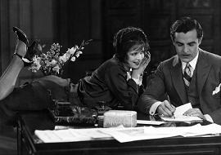  Clara Bow - the 'It' girl, playing self-confident shop-girl Betty Lou Spence, who has ‘it’ and is ‘it’, flirting with rich businessman Cyrus Waltham.  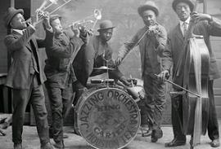  The King & Carter Jazzing Orchestra, 1921.  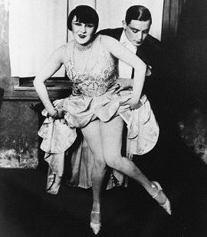  The Charleston
2. Women  How significant were the changes in women's lives in the 1920s?  Argument 1 - VERY significant:  a. Work: Many women had taken over jobs traditionally reserved for men (such as manufacturing), and 1920-29 the number of working women increased by 25%; many went to be teachers and secretaries.  b. Vote: In 1920 the 19th Amendment gave women the vote. The former suffrage campaigners formed themselves into the Woman's Joint Congressional Committee, which lobbied successfully for a Maternity and Infancy Protection Act (1921), equal nationality rights for married women (1922), and the Child Labor Amendment (1925).  c. Flappers: dumped the old restrictive fashions, corsets etc. in favour of short skirts, short hair, and the flat-chested 'garconne' look. Many of them wore men's clothing. They smoked, drank, used make-up, played tennis, and danced wildly in jazz clubs. Some were openly lesbian, others were sexually active.  Argument 2 - NOT significant:  a. Work: most working women were in low-paid jobs, and they were paid less than men for the same job. 10 million women were working in 1930 ... but this was still only a quarter of the females age 15 and over; the rest worked for free in the home and on the farm.  b. Vote: Apart from exceptions such as Florence Kelley and Alice Paul, few suffrage campaigners went into politics; they gave up politics and returned to being housewives. Women campaigned in vain after 1920 for an Equal Rights Act.  c. Flappers: The flappers scandalised many Americans - the Anti-Flirt Association tried to persuade young Americans to behaved decently. Most girls, especially in rural America, still behaved 'decently', got married and had babies. | 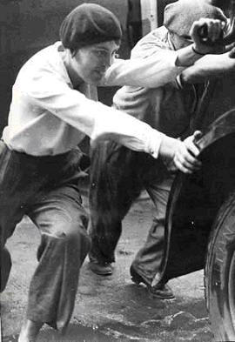  The 'flapper', wearing trousers and pushing a car along with the men - or is this a posed photograph?

3. Race Relations  How far were the 1920s a time of racism and discrimination for Black Americans?  Argument 1 - A time of racism [HACKLE]:  a. Hostility to immigrants: and the Red Scare' (see p.5 above)  d. American Government: refused to pass laws banning lynchings or giving Black Americans the vote.  c. Jim Crow Laws: the name for laws passed in the southern states which prevented Black Americans from mixing with whites ('segregation'), denied them equality of education and civil rights, and prevented them from voting.  b. Ku Klux Klan: an organisation to maintain WASPs supremacy, which had 5 million members by 1925. Many supporters were poor whites, who did not want Blak Americans to be their equals/fear they would take their jobs, but many were racism wealthy white Americans. They wore white sheets and hoods, and marched with burning crosses. They spoke with each other in a secret language which they called 'Klonversations'. They attacked, tortured and killed Black Americans, but also Jews and Catholics and 'immoral' people such as alcoholics.  e. Lynchings: mobs of white people often hanged ('lynched') Blacks Americans whom they suspected of a crime (usually the police turned a blind eye).  f. Even in the north: Black Americans ended up with the low-paid menial jobs, such as janitors, bootblacks, cooks, houseboys, baggage handlers, waiters, doormen, dishwashers and washroom attendants. In 1919, white Americans in Chicago rampaged through Black neighbourhoods after a drowning black man clinging to a log had drifted into a whites-only swimming area.  Argument 2 - A time of flowering [RHINO]:  a. Role models: some Black Americans became famous - the sprinter Jesse Owens, the baseball player Jackie Robinson, the dancer Josephine Baker. They were an inspiration to other Black Americans.  b. Harlem Renaissance: a cultural flowering in the New York Black neighbourhood of Harlem, based on jazz, but also excellent Black architects, novelists, poets and painters. Many of these believed in 'Artistic Action' - winning equality by proving they were equal.  c. Identity: in 1925 Alain Locke wrote The New Negro, who had to smash the old image of 'Uncle Tom' and 'Sambo', and develop a new identity, 'uplift' the race and fight for equality. There were Black newspapers and magazines. This was the time when the phrase was coined: 'Black is Beautiful'.  d. NAACP: Set up in 1909, it campaigned for civil rights.  e. One-and-a-half million Black Americans migrated from the south to the north. Although many of them ended up in low-paid jobs, some of them formed a new Black middle class, and were educated at university. | 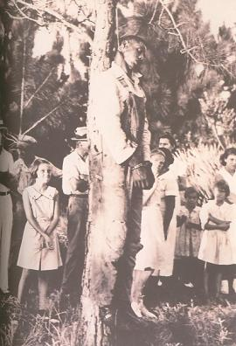  A lynching (1935) - note the children.  Source A  In the morning, a Black mother sent her children to a school for colored children only. Going to town, she sat at the back of the bus, in the seats for coloreds. She went to the posy office for coloreds, visited the library for coloreds, and walked in a separate park. When she went shopping, she stood in line, so White women could go in front of her.  Her husband went to work, but he was not the boss; that was a job for a White man. He used a separate rest room, and went to a separate toilet.  John D Clare, The Black Peoples of America (2001)

 | 4. Prohibition  In 1919 - as the result of a long and powerful campaign (see Source B) - the 18th Amendment to the Constitution made the manufacture, transport or sale of alcoholic drinks illegal. The Volstead Act, passed at the same time, declared any drink more than 5% proof 'alcoholic'.  Argument 1 - A failure [DAMAGE]:  a. Drinking continued: impossible to enforce (not enough police - only 4000 agents, many of whom were sacked for taking bribes).  b. Available: the liquor trade just 'went underground'. speakeasies (illegal bars), moonshine (illegally-made alcohol), bootlegging (smuggling alcohol to sell). It is sometimes asserted that there were more speakeasies than there had been saloons (not true, but there were 200,000 speakeasies in 1933).  a. Made criminals of ordinary people  a. Adverse effects: moonshine was poor quality and sometimes killed people. 'Jackass brandy' caused internal bleeding, 'Soda Pop Moon' contained poisonous alcohol.  a. Gangsterism flourished running the illegal trade: It became hugely profitable, and led to a growth of violence, protection rackets etc. associated with the illegal trade (see 'Organised Crime' below). The general flouting brought the rule of law in general into disrepute as police 'turned a blind eye. Corruption grew.  a. End: in 1933 the 21st Amendment abolished Prohibition (= 'proved' that it failed).  Argument 2 - A Success [ALE]:  a. Alcohol destroyed: in 1929, 50 million litres of illegal alcohol were discovered and destroyed.  b. Legacy: the actual consumption of alcohol fell, not just during prohibition, but for many years after - did not reach pre-1914 levels until 1971.  c. Eliot Ness and the Untouchables: became famous as examples of the high standards police SHOULD achieve. |  | Source B  Why Prohibition [ACRIME]  a. Anti-Saloon League - campaigned that drink hurt families because men wasted money on beer, that it ruined their health and lost them their jobs, and that it led to domestic violence and neglect.  b. Christian organisation – esp. Women's Christian Temperance Union – supported prohibition. (The early 20th century was a time of Christian revival.)  c. Rural America – scandalised by behaviour in the towns – supported it.  d. Isolationism – it was said that money spent on drink ‘flew away to Germany’ because much of the beer drunk in America was brewed there.  e. Madness, crime, poverty and illness were seen as caused by alcohol - many (including BOTH my grandparents, 'signed the pledge' never to drink.)  f. Easy Street – Charlie Chaplin’s comic film (1917) showed how drink damaged, and Christianity nurtured, families' happiness and prosperity.  Source C  Why Prohibition Failed [NCP]  a. Not enough Agents - only 4000  b. Corruption and bribes – one tenth of Agents sacked for taking bribes  c. Public support – most people did NOT support a ban.
 | 5. Organised Crime  Organised crime stepped in to take over from the breweries and spirits manufacturers:  a. They ran the speakeasies, and bootlegging.  b. They also ran protection rackets, prostitution and drug-running.  c. They bribed trade union leaders, police, lawyers, judges and even Senators.  d. The most famous gangster was Al Capone, who earned $100,000 a year from beer sales alone, ran a private army of more than 700 mobsters, and is thought to have murdered more than 200 opponents.  e. They fought with each other for control of their 'territory' - the most famous incident was the  St Valentine's Day Massacre in 1929, when 'torpedoes' from Capone's gang shot dead 7 members of Bugs Moran's gang.  Source D  Prohibition is a business. All I do is supply a public demand. I do it in the best and least harmful way I can  Al Capone |  | 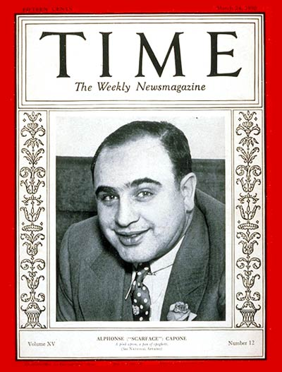  In 1930, Al Capone made the front page of Time magzine

Why did the USA fall into depression in 1929?

This huge topic is really two topics.
The first question is the easier question to answer:
- Why was there a Great Crash on the American Stock Market in 1929?

The second is much harder:
- Why was there a Great Depression in the 1930s?

Many textbooks just assume that the Great Crash led on to the Great Depression, but this is far from proved, and most economists state that the Great Crash did NOT cause the Great Depression.

Background knowledge
Companies sell shares as a way of raising money, and they attract buyers by giving them a share (hence the name) of the profit at the end of each year (this is called the 'dividend'). In America in 1929 about 1.5 million people owned shares.
If a firm is doing well, the value of its shares rise, and people can sell them for more than they bought them. When there is a 'bull' market (when share prices are generally rising) people buy shares solely hoping to make a profit. These people are called 'speculators' and in 1929 about 600,000 of the 1.5 million shareholders were active speculators.

A 'bear market' is one where prices are falling. Speculators fuel a bull market by gambling on future price rises, but they can turn a bear market into a crash by desperately trying to get rid of their shares before they fall any further.

1. Why was there a Great Crash in 1929?  Historians are fairly much agreed why the Wall Street Crash of 1929 happened.  1. Wall Street over-heated:  ● Between 1924-29 the value of shares rose 5 times.  ● Share prices rose way beyond what the firms they were shares were worth; only speculation kept up the over-inflated prices.  2. Speculation:  ● Many people became speculators - 600,000 by 1929.  ● Many people were buying shares 'on the margin' (borrowing 90% of the share value to buy the shares, hoping to pay back the loan with the profit they made on the sale). American speculators borrowed $9bn for speculating in 1929.  ● Some firms which were not sound investments floated shares (e.g. one was set up to develop a South American mine which did not exist), but people still bought them, because they expected to make a profit in the bull market.  3. Corruption - the Senate Committee set up to investigate the Great Crash found that there was a corruption and 'insider-trading' between the banks and the brokers.  4. Panic:  ● There were losses of confidence in March and September (when the economist Roger Babson forecast a crash), but the banks papered over the cracks by mass-buying of shares to help the market.  ● On Thursday 24th October 1929, nearly 13 million shares were sold in a panic, and prices crashed.  ● The banks tried to shore up the market again, but on Monday there were heavy selling; the banks realised it was hopeless and stopped buying shares.  ● Speculators panicked at the thought of being stuck with huge loans and worthless shares. On Tuesday 29th October the market slumped again, when 16 million shares were sold. | Source A  The rich man's chauffer drove with his ears laid back to catch the news of an impending move in Bethlehem Steel; he held 50 shares himself. The window-cleaner at the banker's office paused to watch the ticker, for he was thinking of converting his savings into a few shares of Simmons ... a broker's valet who made nearly a quarter of a million on the market, a trained nurse who cleaned up $30,000 following the tips given her by grateful patients; and the Wyoming cattleman, 30 miles from the nearest railroad, who bought or sold 1,000 shares a day.  Frederick Lewis Allen, Only Yesterday (1931)  Allen gives the impression of a public 'drunk' with share-buying. In fact, this was far from the truth.

2. Why was there a Great Depression in the 1930s?
Many textbooks simply link the Great Crash and the Great Depression together - what caused the Great Crash is assumed to have caused the Great Depression which followed it.

Actually there was no reason why a stock market crash need have caused the Depression, so economists have tried to find reasons why the Crash slid into Depression. Their explanations are VERY complicated and theoretical, but some of their main ideas (MUCH simplified) are:

1. Explanations at the time
a. Basically, at the time, people hadn’t a clue what had caused the depression. Herbert Hoover argued that it was the European financial collapse of 1931 that turned it into the Depression; (so it was Europe’s fault, not America’s).
b. The explanation of British economist John Maynard Keynes in 1936, who wrote General Theory of Employment, Interest, and Money, was that the cause was a DROP IN SPENDING, caused by people saving too much. This was certainly what Roosevelt believed, and his answer was simply to pump money into the US economy; increased spending, however, did not cure the Depression.

2. Great Crash
a. You will often hear it said that the Great Crash didn’t cause the Great Depression. There were only 1.5 million shareholders, and only 600,000 speculators – so why should their misfortune cause a Depression in a country of 123 million?
b. However, you will remember that much of the bull market had been financed by loans – in 1929 brokers’ loans amounted to $8.5 billion. Much of this money had been advanced by the banks, and by the big companies (in 1929, 200 companies controlled half of US industry). So when the speculators crashed, many banks went bankrupt, and half of US businesses was damaged, so the whole US economy suffered.

3. The Fed
a. (‘The Fed’ was the US Federal Reserve – the American ‘Bank of England’.)
In the 1940s, Milton Friedman came up with a theory about the cause called ‘monetarism’ – he believed that price changes were caused by a reduction of money in the economy. He therefore blamed the US Federal Reserve which in 1931 raised interest rates – which, he claimed, led to a reduction in the money supply. His famous saying was that ‘the Fed put the Great in the Great Depression’.
b. This was made worse, Friedman added, when the banks began to go bankrupt after 1931, and because the amount of money in the economy was linked to the Gold Standard (meaning that the government would only issue as much money as it could redeem in gold).

4. Tariffs
a. In 1930, fearing for the US economy, the government passed the Smoot-Hawley Tariff – a new, even heavier tariff law.
b. Sixty countries passed retaliatory tariffs in response and world trade slumped. This damaged US industry, especially agriculture.

5. Maldistribution of wealth
a. Nowadays, historians think that a major cause of the depression was the inequality of wealth in America. There were some extremely rich people, and huge numbers of extremely poor people – the top 5% owned a third of the wealth, while 40 per cent of the population were living in poverty.
b. It wasn’t that there was too little money, but it wasn’t in the hands of the people who would spend it. Consequently, Americans produced too much and bought too little, and prices plummeted.

6. Weaknesses in the economy
You will remember that Agriculture, and the Coal, Iron and Textiles industries were all experiencing problems in the 1920s. When the Depression started, they were not strong enough to cope, and collapsed quickly.

7. Cycle of Depression
As more banks and companies failed, and people were put out of work, they had less to spend, and so more companies went bankrupt and made their workers unemployed etc. Once the Depression had taken hold, it simply spiralled down worse and worse.

What were the effects of the Depression on the American people?

Top of Form
... the most serious economic depression the world had ever seen...
Ben Walsh, GCSE Modern World History (2004)
commenting on the different theories about why the USA fell into depression.

1. The Depression was terrible  These are the 'facts' of the Depression as you will see them presented in most textbooks.  (Some Farmers Were Handling Hardship Very Badly)  1. Statistics:  ● In 1931, 238 people were admitted to hospital suffering from starvation.  ● International trade slumped from $10bn in 1929 to only $3 bn in 1932.  ● 5000 banks went bankrupt 1929-1932, including the Bank of America.  ● In 1932 a quarter of a million Americans had their homes repossessed, and a fifth of all farmers lost their farms.  ● In 1932, 20,000 companies went out of business.  ● By 1933:  - Industrial production had fallen by 40%  - Prices had fallen 50%  - Wages had fallen by 60%  - Share prices had fallen by 80%  - 5000 more banks went bankrupt.  - 25% of Americans were unemployed.  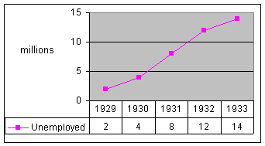  2. Farmers:  ● The depression was particularly fierce in agriculture, and things were made worse by the ‘dust bowl’ caused by over-farming.  ● Many farmers could not afford their mortgage repayments and many ‘Okies’ (from Oklahoma) and ‘Arkies’ (from Arkansas) had to abandon their farms and go fruit-picking in California (the famous novel The Grapes of Wrath is about this).  3. Welfare and Despair:  ● America and no Welfare State. Many unemployed Americans were reduced to picking over rubbish dumps or begging (cf the song ‘Buddy, can you spare a dime’).  ● SOME towns set up soup kitchens and groups like the Salvation Army (and even Al Capone) organised charity hand-outs – hence the term ‘on the breadline’.  ● In the land of opportunity this was seen as a terrible failure, and 23,000 people committed suicide in 1932 alone.  4. Hobos and Hoovervilles:  ● Homeless people went to live in shanty towns called ‘Hoovervilles’ (as an insult to President Hoover). ‘Hobos’ travelled round looking for jobs, usually riding illegally on freight trucks.  5. Hatred of Hoover:  ● The government did not know how to stop the Depression, and Hoover believed in ‘rugged individualism’, and stuck to the idea that it was not the government’s job to interfere with business.  ● In 1930 the Smoot-Hawley Act raised tariffs, in 1931 the Fed raised interest rates, and in 1932 the government raised taxes - all three simply made the Depression much worse.  ● Most Americans came to blame the President for the Depression. Shanty towns were called ‘Hoovervilles’, but there was also ‘Hoover leather’ (cardboard soles for shoes) and ‘Hoover blankets’ (newspapers). ‘In Hoover we trusted, but now we are busted’.  6. Violence:  ● There were many protest marches and riots. When banks tried to re-possess some farms, local farmer banded together and drove them off with pitch-forks.  7. Bonus Army:  ● In 1932, 20,000 unemployed ex-soldiers set up a Hooverville in Washington to ask for their war pension (‘bonus’) to be paid early; Hoover set the army on them, who drive them away with guns and tear-gas. | Source A  Last summer, in the hot weather, when the smell was sickening and the flies were thick, there were 100 people a day coming to the dumps. A widow, who used to do housework and laundry, but now had no work at all, fed herself and her 14-year-old son on garbage. before she picked up the meat she would always take off her glasses so that she couldn't see the maggots.  New Republic magazine (1933)  Source B  There is not an unemployed man in the country that hasn't contributed to the wealth of every millionaire in America. The working classes didn't bring this on, it was the big boys...  We've got more wheat, more food, more cotton, more money in the banks, more everything in the world than any other nation that ever lived ever had, yet we are starving to death. We are the first nation in the history of the world to go to the poorhouse in an automobile.  Will Rodgers (1931)

2. Or was it?

1. Hoover did not do nothing:
● In 1930 he cut taxes and the Committee for Unemployment Relief was formed.
● In 1931 he gave $4000 million to state governments to set up schemes to provide work (e.g. the Hoover Dam). The Davis-Bacon Act encouraged firms to maintain high wages by requiring "prevailing" (union) wages to be paid on federal construction contracts.
● In 1932 he passed the Emergency Relief Act ($300 million to provide unemployment pay) and the Reconstruction Act (which set up the Reconstruction Finance Corporation to provide $1500 million of loans to help businessmen). The Norris-La Guardia Act protected trade unions and the Glass-Steagall Act helped banks by making it easier for them to borrow from the federal reserve.
All this is usually either not mentioned at all, or dismissed as ‘too little, too late’. In fact, it was exactly what the ‘New Deal’ was later to copy.

2. Not all industries or places suffered:
● The Depression was worst in farming, and in the old industries (80% of steel workers were unemployed in Toledo. 'New' industries (such as films, electronics and airplanes) continued to expand and pay high wages.
● Many people who managed to keep their jobs were BETTER off, because prices were much lower.
● Certain areas of the economy thrived. The Empire State Building was finished in 1931, and the San Francisco Golden Gate Bridge was started in 1932
Bottom of Form

What did Roosevelt introduce to deal with the Depression?

Top of Form
Mr. Roosevelt is the only man we ever had in the White House who would understand that my boss is a sonofabitch.
North Carolina mill worker (c. 1935)

In the 1928 election, President Hoover had promised Americans ‘a chicken in every pot and a car in every garage ... but by 1932, America was in depression.
In the November 1932 election, therefore, Roosevelt promised ‘a new deal for the American people’ if they elected him. The result was a landslide – Roosevelt won 42 of the 48 states, the biggest US election victory ever.

In his Fourth Fireside Chat (June 1934), Roosevelt said that his ‘New Deal’ had three related steps:
• Relief (helping the poor and unemployed to survive)
• Recovery (getting the economy going again) and
• Reform (changing things so a depression could never happen like that again).

Roosevelt's New Deal had two parts
Can Fdr Achieve ... New Social Standards 'N Fairness
First, he set about offering relief and trying to get the economy to recover.
After 1935, however, he set about a much more radical agenda of social reform (the ‘second New Deal’).

First, however, he was faced by a crisis. During the four months Roosevelt was waiting to come into office (March 1933), the economy declined further, culminating in a banking crisis. At the beginning of March, millions of people marched into their banks and demanded their money – as they were allowed – in gold. It was impossible; banks in 34 states closed and padlocked their doors. The entire financial system of the USA was in the verge of collapse.
Bottom of Form

The First New Deal  Roosevelt persuaded Congress to give him emergency powers from 9 March to 16 June 1933 (the 'Hundred Days'). Although many of Roosevelt's ideas were not new (some just copied Hoover's), 1933 - especially the 100 days - saw a burst of legislation to tackle the Depression like never before.  1. Confidence:  Roosevelt undertook a series of measures to keep the American people on his side.  a. Abolished Prohibition  - He said: ‘I think this would be a good time for a beer”. This restored faith in the government because it stopped the humiliation of the government’s laws being openly ignored.  - (It also increased the government’s revenues.)  b. Fireside Chats  - FDR made sure that everyone who sent him a letter got a reply (he got up to 8,000 letters a day), and that everyone who telephoned the White House was never cut off.  - FDR described his policies in radio broadcasts called ‘fireside chats’.  c. Bank holiday  - The Emergency Banking Act closed the banks for four days. The government checked that all were financially sound, and when they reopened, they reopened with the backing of the Federal Reserve.  - This restored confidence in the banks, and people deposited their money there again.  d. Stock Exchange  - The Securities and Exchange Commission introduced rules for the Stock Exchange to prevent another Crash like 1929.  2. Finance and Economy:  Roosevelt believed that he had to make sure that the economy was ‘sound’.  a. Budget  - He did not run deficit budgets (i.e. it did not spend more than it gathered in taxes).  - He CUT the pay of government employees by 15%.  (These measures actually made the depression worse.)  - The government borrowed huge amounts of money to finance the New Deal, but it spent it on projects that were planned to pay back eventually.  b. Bankruptcies  - The Farm Loan Act and the Bankruptcy Act prevented banks from foreclosing on solvent businesses until they had had a chance to borrow from the Federal Reserve.  - The Home Loan Act and the Home Owners Loan Corporation did the same for ordinary home owners.  c. Prices and Wages  - The Agricultural Adjustment Act (AAA) paid farmers to take fields out of production; the idea of this was to stop over-production and to drive up prices.  - The NRA (National Recovery Administration) was set up, where businessmen joined a ‘Roll of Honour’ (and were allowed to show a blue eagle symbol) where they promised to cut production and pay good wages – 2.5 million firms, employing 22 million people, joined the scheme.  - FDR also abolished Child Labour – this put more adults into work.  d. Currency  You will read in some books that FDR abolished the gold standard (linking the value of the dollar to a certain weight of gold). This is not true. He did:  - stop people owning gold (they had to deposit it in banks)  - make the banks give all the gold to the government  - increase the price of gold from $20 to £35 an ounce.  This stopped people hoarding/saving their money, and increased the amount of government reserves. Since the dollar was still linked to gold, moreover, many foreign investors bought American dollars for gold, which increased the amount of government reserves.  3. Alphabet Agencies:  FDR set up what came to be called the ‘alphabet agencies’ because their names were reduced to acronyms. The main ones were:  a. CCC (Civilian Conservation Corps):  provided paid conservation work to give unemployed young men jobs – by 1941, 2.5 million had taken part PLUS millions of trees panted/ parks and forest areas developed  b. FERA (Federal Emergency Relief Administration): provided matched funding to help states organise payments to the unemployed and homeless.  c. WPA (Works Progress Administration):  ran projects which provided work for the unemployed, e.g. building airports, schools, hospitals or bridges – millions earned a small wage and felt valuable.  d. TVA (Tennessee Valley Authority):  built 21 dams in ten years – stopped flooding, provided cheap electricity and provided work. | The Fireside Chats  (NB they are worth reading or listening to – they will give you the best impression of what FDR was about.)  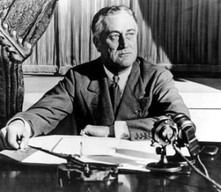  These chats were brilliant propaganda and had three key aspects:  - Homeliness – the chats were delivered “like a father discussing public affairs with his family in the living room”.  - Reasonableness – FDR said that he was not going to make false promises, and that he would not succeed every time  - Blame – he spoke of ‘the 10%’ who wanted the New Deal to fail – the rich.  Ordinary people believed that he was fighting the rich and selfish in their behalf – as a result, even though the gains of the first New Deal were not great, FDR won the 1936 election by another landslide  Source A  I can assure you that it is safer to keep your money in a reopened bank than under the mattress.  1st Fireside Chat, (March 1933)  Source B  Dear Mr. President: This is just to tell you that everything is all right now. The man you sent found our house all right, and we went down to the bank with him and the mortgage can go on for a while longer. You remember I wrote you about losing the furniture too. Well, your man got it back for us. I never heard of a President like you.  Letter to the President from an old man and his wife, (summer, 1933)

Bottom of Form
 | The Second New Deal  In 1935, Roosevelt's New Deal was still hugely popular with the people, but it was running into opposition (see next page for greater detail).  The most important elements of this opposition were:  1. The Supreme Court, which ruled the NRA and the AAA illegal, because they took away the right of states to run their own affairs.  2. Some businessmen, who attacked and ignored the NRA saying that it was expensive and wasteful.  Therefore, in the run up to the 1936 election and after it, Roosevelt followed a much more radical 'reform' agenda.  1. National Labour Relations Act (1935):  ● Also known as the Wagner Act.  ● To replace the banned NRA.  ● Protected workers' right to join a trade union/ .  ● Set up the National Labour Relations Board (NLRB) to prevent employers from victimising workers.  2. Soil Conservation Act (1935):  ● To replace the banned AAA.  ● Allowed the government to continue subsidising farmers.  3. Social Security Act (1935):  ● Provided America's first system of social welfare.  ● set up a national system of old-age pensions  ● gave help to people with physical disabilities  ● gave help to children in need  ● set up a national system of unemployment insurance.  4. National Housing Act (1937):  ● Provided loans to buy houses  ● Reduced excessive rents.  5. Fair Labour Standards Act (1938):  ● Set hours and conditions of work  ● Fixed a minimum wage. | Source C  But here is the challenge to our democracy: In this nation I see tens of millions of its citizens - a substantial part of its whole population - who at this very moment are denied the greater part of what the very lowest standards of today call the necessities of life...  I see millions denied education, recreation, and the opportunity to better their lot and the lot of their children.  I see one-third of a nation ill-housed, ill-clad, ill-nourished...  The test of our progress is not whether we add more to the abundance of those who have much; it is whether we provide enough for those who have too little.  2nd Inaugural Address (1937)  Source D  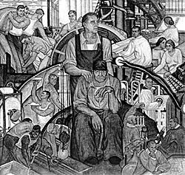  This 1934 mural sees Roosevelt as the protector and friend of the working man.

How successful was the New Deal?

Successes  1. Relief  Millions of people received relief, help with their mortgage, jobs etc. from the alphabet agencies.  2. Roads and buildings  The PWA and the TVA provided valuable economic and social infrastructures, such as roads, airports, schools, theatres, dams etc.  3. Reform  Roosevelt's new laws about social security/ minimum wage/ labour relations and trade unions survived and protected ordinary people’s rights and conditions. Democracy survived in America (unlike Italy and Germany)  4. Roosevelt  became the people's hero - he was elected four times.  5. Repercussions  Democracy survived in America (unlike Italy and Germany). The New Deal became a model of how a democratic government ought to behave - arguably influenced the British Welfare State of 1948. And in 1998, when the Labour Government of Britain was trying to introduce new laws to help poor people, it called it: a New Deal. | Source A  Whether the New Deal was a success or failure is not easy to judge.  Individual programmes were a success, such as T.V.A. Others, such as A.A.A. succeeded in getting food prices to rise, which was good for the farmers, but did not help the millions who were out of work and hungry.  The New Deal did not solve the problem of unemployment,  but merely made the situation not as bad as it might have been’  Pupil's GCSE essay for OCR (2003)
Weaknesses and Failings  1. Did not end the Depression  - indeed, Roosevelt's insistence on a balanced budget, healthy interest rates and ‘sound money’ may have helped to continue it. Roosevelt had no new ideas how to end the depression – just Hoover’s schemes only bigger. By 1935 he had failed to end unemployment (which was only down to 10.6 million), and – although unemployment fell to 7.7 million in 1937 – when Roosevelt tried to cut back government expenditure in 1938, it rose again to 10.4 million. It is not really fair to criticise Roosevelt for this - no one at that time knew how to end the Depression - but the Depression did not end until the Second World War got production going again.  2. Damaged Blacks and immigrants  – in fact, many were laid off as a direct result of the New Deal’s attempts to give workers rights.  3. Determined Opposition (BRASS)  a Businessmen hated the New Deal because it interfered with their businesses and supported workers’ rights. Rich people accused Roosevelt of betraying his class. Henry Ford hired thugs to attack his trade union workers.  b Republicans hated the expenditure, which they said was wasteful (‘boondoggling’ – jobs for the sake of jobs). CWA had to be abolished in 1935, though immediately replaced by the PWA. After 1938, Republicans took over the Senate, and Roosevelt was unable to get any more New Deal legislation through.  c Activists like Huey Long (Senator for Louisiana who started a Share the Wealth’ campaign to confiscate fortunes over $3m) and Francis Townsend (who campaigned for a pension of $200 a month) said it did not go far enough.  d State governments opposed the New Deal, saying that the Federal government was taking their powers.  e The Supreme Court ruled that the NRA codes of employers’ conduct, and the AAA programme, were illegal because they took away the States’ powers. Because of this, in 1937, Roosevelt threatened to force old Supreme Court judges to retire and to create new ones; the crisis was averted when the Supreme Court reversed its decisions. | 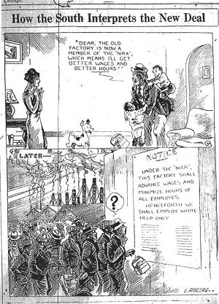  This cartoon shows New Deal legislation throwing Black workers out of a job. Other people accused the AAA of driving farm labourers from the land by making farmers cut back production.  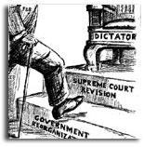  Some people claimed that by trying to 'pack' the Supreme Court,  Roosevelt was trying to make himself a dictator.

